**Problem Statement:**

Get a list of employees who receive a salary less than 100, compared to their immediate employee with higher salary in the same unit

Creating table and loading database

Hive Program & Output

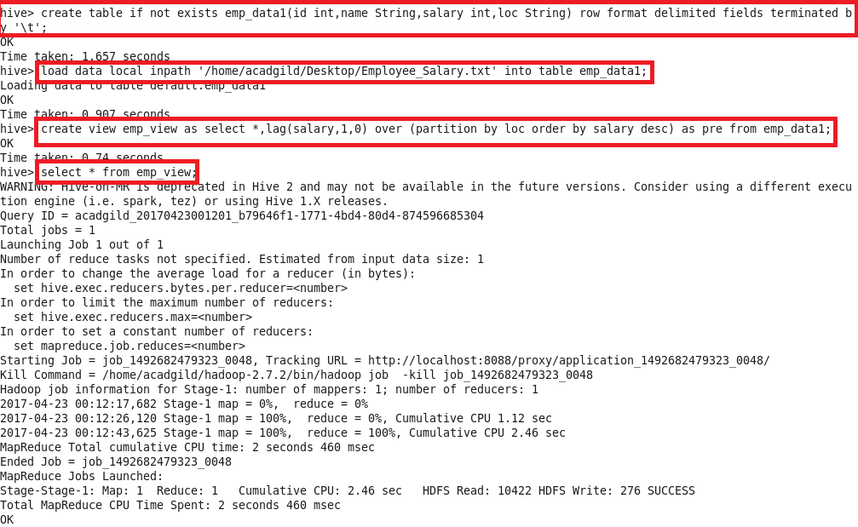

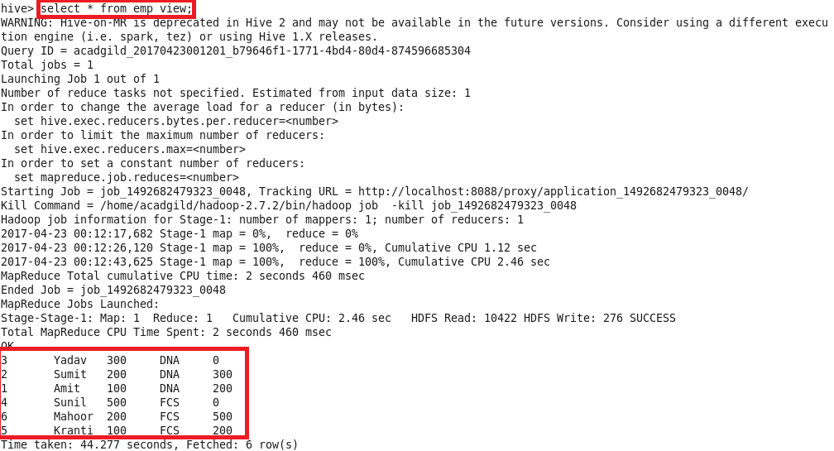

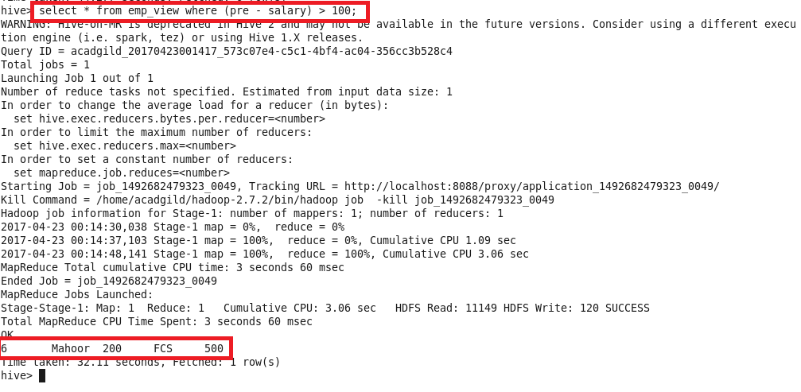

Problem Statement:

List of all employees who draw higher salary than the average salary of that department

Hive Program & Output

